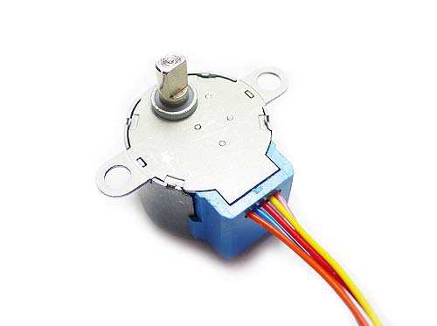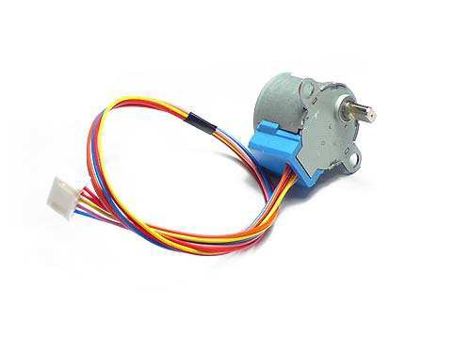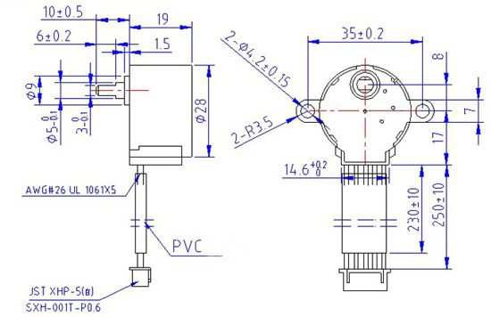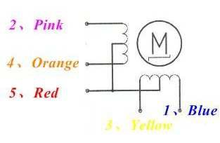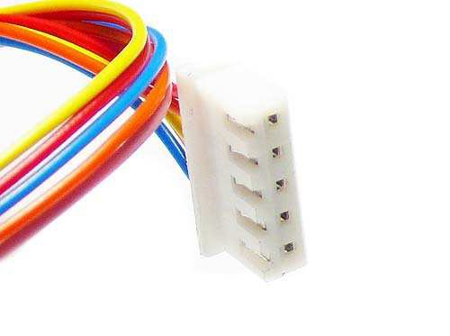

**28BYJ-48 – 5V Stepper Motor**

The 28BYJ-48 is a small stepper motor suitable for a large range of applications.

Rated voltage ： 5VDC

Number of Phase 4

Speed Variation Ratio 1/64

Stride Angle 5.625° /64

Frequency 100Hz

DC resistance 50Ω±7%(25℃)

Idle In-traction Frequency > 600Hz

Idle Out-traction Frequency > 1000Hz

In-traction Torque >34.3mN.m(120Hz)

Self-positioning Torque >34.3mN.m

Friction torque 600-1200 gf.cm

Pull in torque 300 gf.cm

Insulated resistance >10MΩ(500V)

Insulated electricity power 600VAC/1mA/1s

Insulation grade A

Rise in Temperature <40K(120Hz)

Noise <35dB(120Hz,No load,10cm)

Model 28BYJ-48 – 5V

P.O. Box 8231 Cherrywood Tauranga New Zealand Phone: ++64 7 578 7739 Fax: ++64 7 578 7749 E-mail: enquiry@kiatronics.com

Website: www.kiatronics.com Copyright  Welten Holdings Ltd - Specifications subject to change without further notice.